
Central Colorado Humanists
2021 College Scholarship Instructions and Application Form
The Central Colorado Humanists is planning to award one or more scholarship/s in the spring of 2021 to local high school seniors planning to attend college in the fall of 2021. Students in non-traditional schools or who are home-schooled are also eligible. Successful applicants will be eligible to apply for an additional scholarship award in their freshman year of college to help meet college expenses during their sophomore year.
Humanists seek knowledge from science, guidance from reason, inspiration from nature and art, and motivation from compassion. We are pleased to be able to offer educational scholarships to students who demonstrate, personify, and aspire to uphold these humanist values. (Please visit our website at www.centralcoloradohumanists.org.)

Eligibility:
- Preference will be given to applicants who reside in and around Chaffee County.
- Applicants must be graduating high school seniors, students who are home schooled or non-traditional school graduates who are planning on attending an accredited university, college or community college beginning in the fall 2021 semester.

- Applicants must have a cumulative 3.0 grade point average.
The deadline for submitting the application and all supporting materials is March 31, 2021.
Finalists may be required to appear before the Scholarship Committee for a personal interview.
Applications are available for download at www.centralcoloradohumanists.org.

The application is complete when the following materials have been received. Please attach items 1, 2, 3, and 5 to a single e-mail, enter “scholarship application” and your name in the subject line and send to centralcoloradohumanist@gmail.com.
- Completed official application (download a copy of the official application and complete it in WORD). Please do not submit applications through a shared Google drive.
- A copy of your official high school transcript and a copy of the official record of your SAT and/or ACT scores, both in PDF format.
- A 750 word (max) essay (in WORD, NOT handwritten) on the following topic:

The integrity of science is being challenged by distortion and disinformation posted on numerous social media sites. How will your college education assist you in an effort to restore respect for scientific integrity and reason?
- Two letters of recommendation from people not related to you. One should be from one of your high school teachers. The other should be from an adult who knows you well and can comment on your character. Please ask these individuals to e-mail their letters of recommendation directly to centralcoloradohumanist@gmail.com. Letters sent by students will not be accepted.
5. A digital photograph, preferably head image, that may be used in scholarship announcements.
(Application follows below)

Application for Central Colorado Humanists’ 2021 College Scholarship
(Download this form, complete it on a computer in WORD and attach the completed document to your email. You may scroll down as necessary to allow sufficient room on the application form for your responses)

Name:

Address

Phone: e-mail:

Current High School:
Current GPA:
- (Home-schooled students: Please list name of curriculum used and include information about that curriculum, including courses completed and grades awarded (required).

- Please list the two- or four-year colleges or universities to which you are applying. (If you have been accepted, please attach a scanned copy of your acceptance letter to your submission email).
- What is (are) your anticipated major(s)?
- How do you plan on financing your college education?
- List the two individuals who will be providing letters of recommendation:
One teacher directly associated with your educational experience:
One adult, not related to you, who knows you well and can comment on your character:
- Please list below your extra-curricular school activities along with the years you were involved in each, the approximate number of hours each year you spent on each activity, and person(s) whom we may contact:

- Please list below your community service activities.
- Please list below any work experience you have.
- (Optional) Please include any additional information that you would like to share with us that may be pertinent to your application and/or financial need.

Attach an essay, of 500 to 750 words, (double spaced and in WORD). See item #3 under materials to include with your application.

TITLE OF YOUR ESSAY:

By checking this box I _______________________________ assure that all information that I
(name)
have submitted is true and accurate to the best of my knowledge and that my essay is my original work.

Please direct any questions regarding the application process to: centralcoloradohumanist@gmail.com

Central Colorado Humanists exists to:
Promote Humanism, a rational philosophy informed by science, guided by reason, inspired by nature and art, and motivated by compassion.
We affirm the dignity of each human being and support the maximization of individual liberty and opportunity consonant with social and planetary responsibility.
We advocate the extension of participatory democracy and the expansion of the open society, standing for human rights and social justice.
Free of supernaturalism, Humanism recognizes human beings as a part of nature and holds that values – be they religious, ethical, social, or political – have their source in human experience and culture.
Humanism thus derives the goals of life from human need and interest rather than from theological or ideological abstractions, and asserts that humanity must take responsibility for its own destiny.

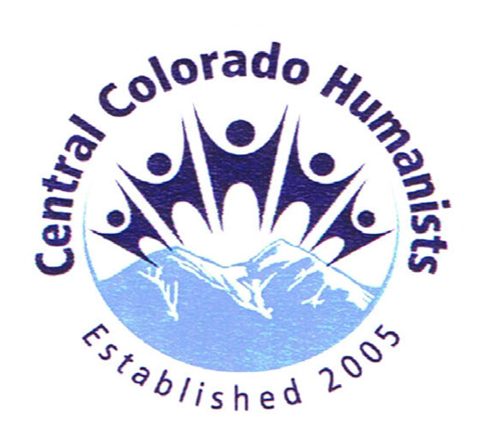

CentralColoradoHumanists.org
Central Colorado Humanists promote:
- Seeking knowledge from science, guidance from reason, inspiration from nature and art, and motivation from compassion;
- Theology-free activism to improve conditions for our planet and its inhabitants;
- Doing good for its own sake, without expectation of reward or punishment after death;
- Separation of government from religion;
- Free thinking and free speech;

Central Colorado Humanists take action…
- Sunday Science: Presentations by local scientists with discussion afterward
- Scholarships to local area high school seniors and college students
- Informative and provocative speakers
- Group discussions
- Art programs
- Social events
- Community Service

- Cooperation with local service organizations

- Annual Darwin Day celebration

